An Internship Report
Of
Python Full Stack Development
Submitted
To
School of Computer Science and Engineering
IILM University, Greater Noida, U.P.
In partial fulfilment of the requirement of degree of
B.Tech (CSE)

By
Roll Number of Student:- 2410031317
Name of Student: DEVESH CHAUDHARY
Batch: 2024-28

CANDIDATE'S DECLARATION
I, DEVESH CHAUDHARY, do hereby declare that the internship report titled "Python Full Stack Development" has been completed by me to fulfil the requirement for the award of the degree of Bachelor of Technology in Computer Science and Engineering. All the references have been quoted and I have not taken as such any material from any other source. I affirm that this report is my own and has not been submitted to any other institute for any degree/diploma requirement, and further I shall be solely responsible for any kind of copyright violation in this regard.
Student Name: DEVESH CHAUDHARY
Roll No.: 2410031317

ACKNOWLEDGEMENT
I am using this opportunity to express my gratitude to everyone who supported me throughout the Internship Program. I am thankful for their aspiring guidance, invaluably constructive criticism, and friendly advice during this work. I am sincerely grateful to them for sharing their truthful and illuminating views on a number of issues related to this work.
I would like to thank the AICTE – EduSkills Virtual Internship Program team and EduSkills Academy for providing me the opportunity and the structured platform to learn and gain hands-on exposure in the domain of Python Full Stack Development. I am also thankful to my institute, IILM University, Greater Noida, and the faculty of the School of Computer Science and Engineering for their continuous support and encouragement.
I express my gratitude to my parents for their blessings.
Signature: Devesh Chaudhary
Student Name: DEVESH CHAUDHARY
Roll No.: 2410031317
TABLE OF CONTENTS
1. Candidate's Declaration
2. Acknowledgementi
3. Internship Completion Certificate
4. Project Description
4.1 Introduction
4.2 Organization Profile
4.3 Problem Statement
4.4 Project Objectives
4.5 Scope of the Project
4.6 Technologies and Tools Used
4.7 System Architecture
4.8 Methodology
4.9 Expected Outcomes
4.10 Certificates of Completion and Communication Proof
5. Bibliography/References
3. INTERNSHIP COMPLETION CERTIFICATE
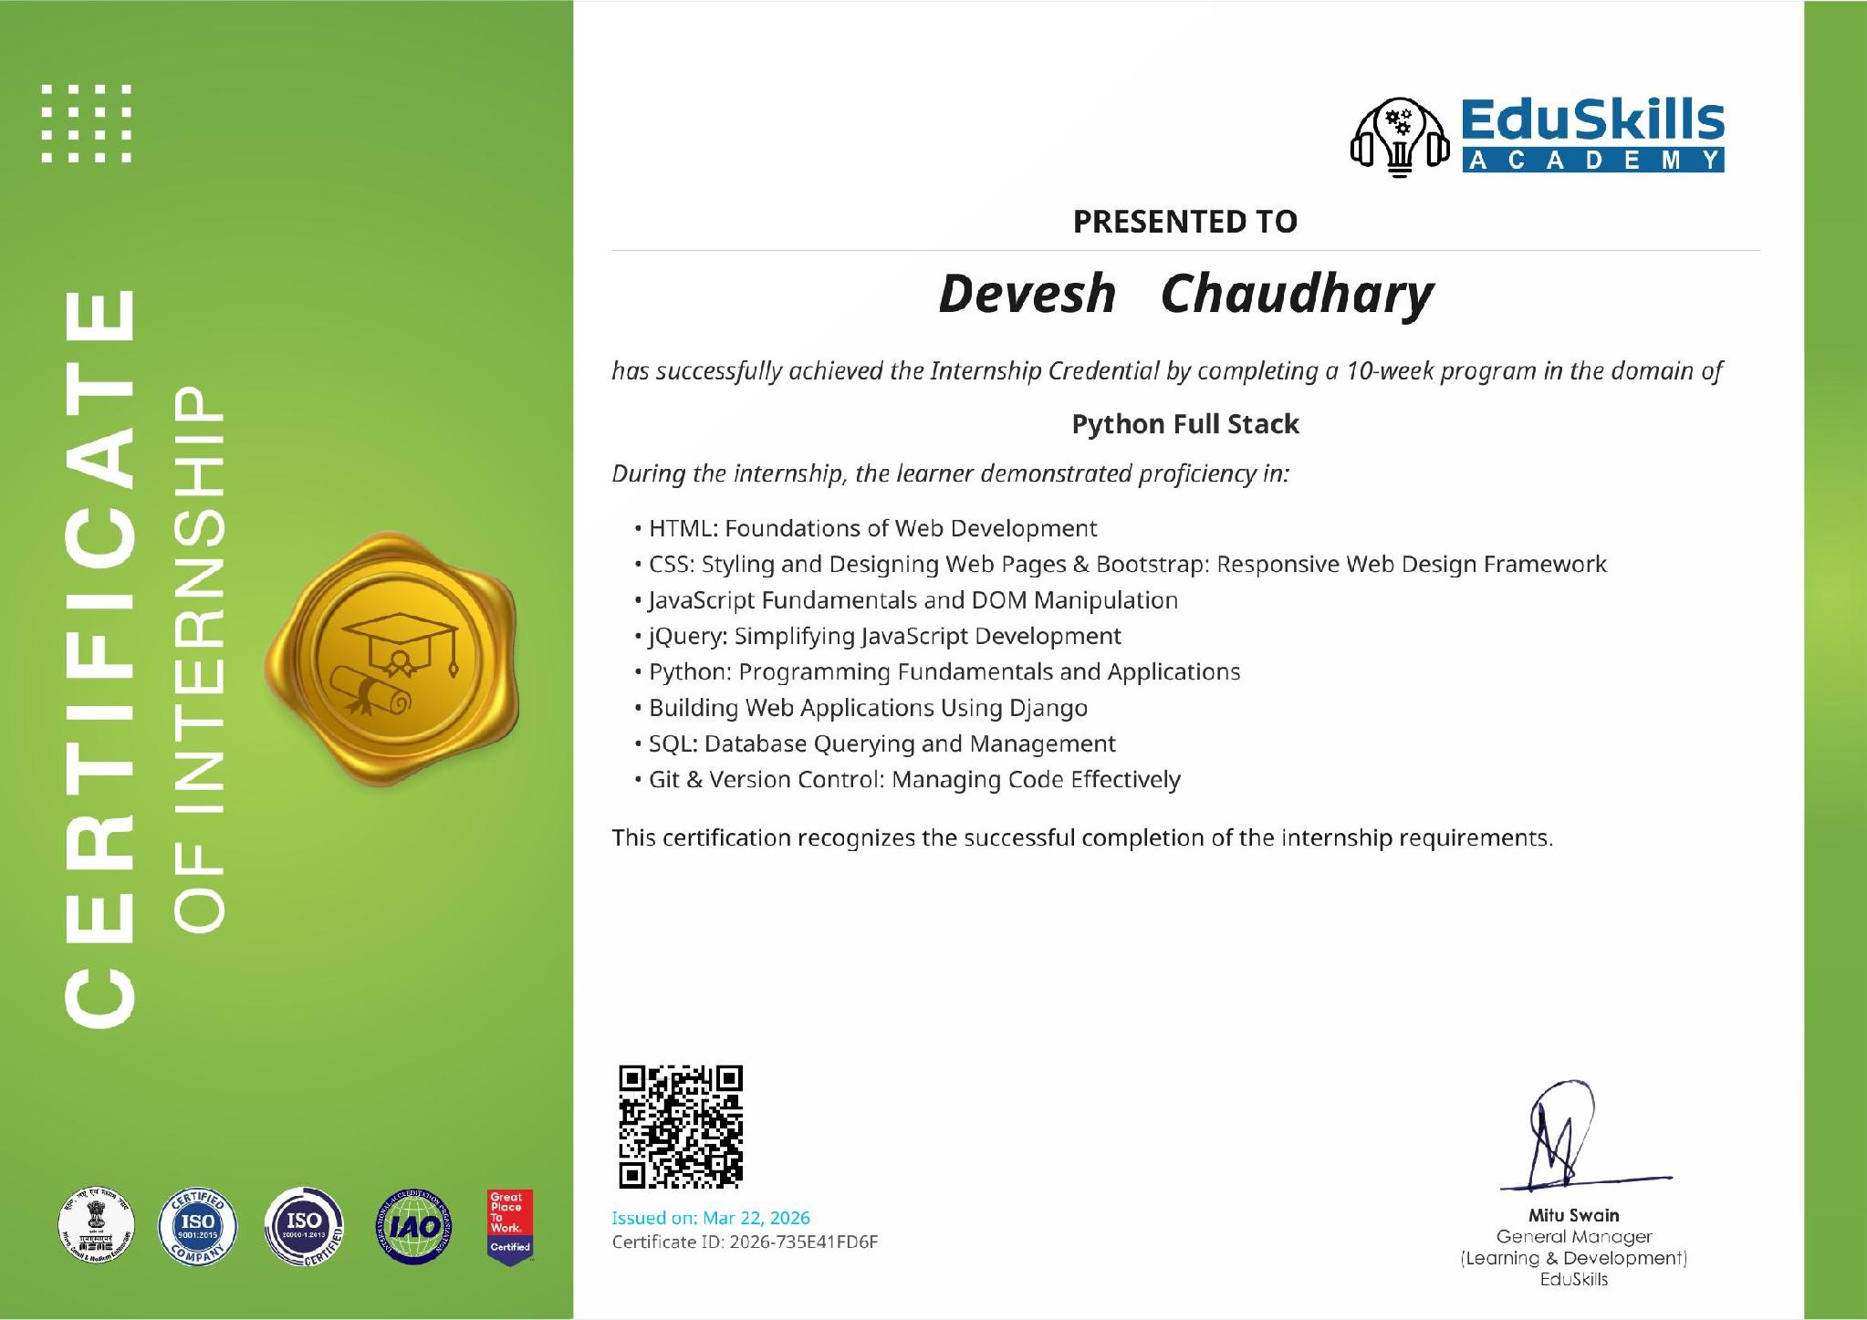

Internship Offer Letter
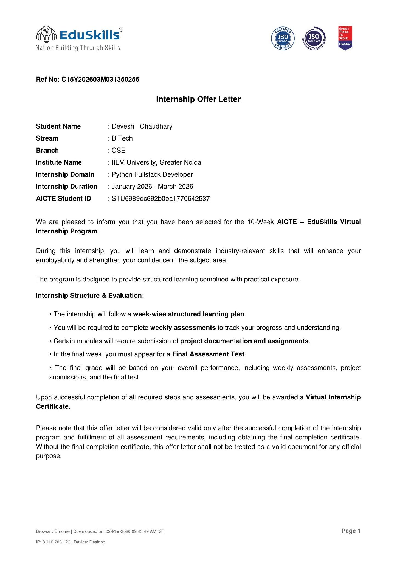

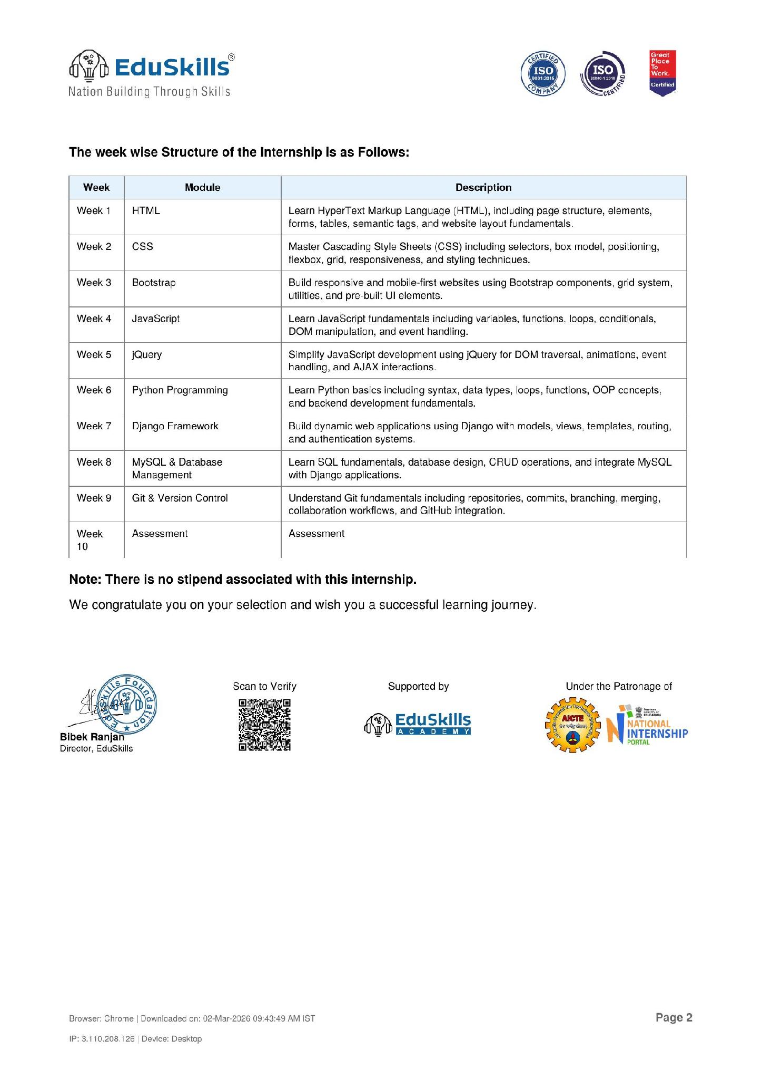

4. PROJECT DESCRIPTION
4.1 Introduction
This report presents a detailed account of the 10-week Virtual Internship undertaken under the AICTE – EduSkills Virtual Internship Program, in the domain of "Python Full Stack Development". The internship was carried out from January 2026 to March 2026 as part of the requirement of the Bachelor of Technology (Computer Science and Engineering) programme at IILM University, Greater Noida. The primary aim of this internship was to bridge the gap between the theoretical understanding of web technologies and their practical, industry-oriented application in building a complete, end-to-end web application – covering both the client-facing frontend and the server-side backend, along with database integration.
The internship followed a structured, week-wise curriculum that combined conceptual learning with hands-on assignments, weekly assessments, and project documentation. On successful completion of all the requirements, including a Final Assessment Test, a Virtual Internship Certificate was awarded by EduSkills Academy.
4.2 Organization Profile
EduSkills Academy is an ISO 9001:2015 and ISO 20000-1:2018 certified organization operating under the theme "Nation Building Through Skills". It partners with the All India Council for Technical Education (AICTE) to run the AICTE – EduSkills Virtual Internship Program, offered under the patronage of the AICTE National Internship Portal. EduSkills designs structured, industry-aligned virtual internship curricula across a range of technology domains – including Full Stack Web Development, Python Programming, Cloud Computing, and Artificial Intelligence – to help engineering students build practical, job-ready skills alongside their academic coursework.
4.3 Problem Statement
Many engineering students learn HTML, CSS, JavaScript, and backend languages such as Python as isolated academic topics, without the opportunity to combine them into a single, working web application. As a result, they often struggle to understand how a frontend interface, a backend framework, and a database work together in a real project, and how tools like Git and GitHub are used to manage that code collaboratively. This internship addressed that gap by taking the learner through the full stack of a web application – from designing a page in HTML and CSS, to making it interactive with JavaScript and jQuery, to building the server-side logic in Python's Django framework, to storing and retrieving data using MySQL, and finally to tracking the codebase using Git.
4.4 Project Objectives
- To understand the fundamentals of HyperText Markup Language (HTML) and build well-structured web pages using forms, tables, and semantic tags.
- To learn Cascading Style Sheets (CSS), including selectors, the box model, positioning, flexbox, and grid, and to create responsive page layouts.
- To build mobile-first, responsive websites using the Bootstrap framework's grid system, components, and utilities.
- To learn JavaScript fundamentals, including variables, functions, loops, conditionals, DOM manipulation, and event handling.
- To simplify JavaScript development using jQuery for DOM traversal, animations, event handling, and AJAX interactions.
- To learn Python programming fundamentals, including syntax, data types, loops, functions, and object-oriented concepts.
- To build dynamic, database-driven web applications using the Django framework, including models, views, templates, routing, and authentication systems.
- To learn SQL fundamentals and database design, and to integrate a MySQL database with a Django application.
- To understand Git and GitHub for version control, including repositories, commits, branching, merging, and collaboration workflows.
4.5 Scope of the Project
The scope of this internship spans the complete development lifecycle of a full stack web application – from designing the user interface with HTML, CSS, and Bootstrap, to adding client-side interactivity with JavaScript and jQuery, to building the server-side application logic with Python and Django, and finally to persisting data using a MySQL database. Version control of the codebase throughout this process was managed using Git and GitHub. The internship was conducted in a virtual, self-paced learning environment provided by EduSkills Academy and did not involve deployment to a live production system.
4.6 Technologies and Tools Used
- Markup & Styling: HTML, CSS, Bootstrap
- Client-side Scripting: JavaScript, jQuery
- Programming Language: Python
- Web Framework: Django
- Database: MySQL
- Version Control: Git, GitHub
4.7 System Architecture
The general architecture followed during the internship for building a full stack web application can be summarized in the following layers:
- Presentation Layer: Web pages built with HTML and styled with CSS and Bootstrap for a clean, responsive layout.
- Interaction Layer: Client-side interactivity and DOM manipulation handled using JavaScript and jQuery, including AJAX-based communication with the server.
- Application Layer: Server-side logic, routing, and authentication implemented using the Django framework (Python).
- Data Layer: Application data modeled and persisted in a MySQL database, accessed through Django's models and querying.
- Version Control Layer: The complete codebase tracked and managed using Git, with collaboration workflows supported through GitHub.
4.8 Methodology
The internship followed a structured, week-wise methodology combining conceptual learning, hands-on practice, and weekly assessments, as summarized in the table below.
Week | Module | Description
Week 1 | HTML | Learn HyperText Markup Language (HTML), including page structure, elements, forms, tables, semantic tags, and website layout fundamentals.
Week 2 | CSS | Master Cascading Style Sheets (CSS) including selectors, box model, positioning, flexbox, grid, responsiveness, and styling techniques.
Week 3 | Bootstrap | Build responsive and mobile-first websites using Bootstrap components, grid system, utilities, and pre-built UI elements.
Week 4 | JavaScript | Learn JavaScript fundamentals including variables, functions, loops, conditionals, DOM manipulation, and event handling.
Week 5 | jQuery | Simplify JavaScript development using jQuery for DOM traversal, animations, event handling, and AJAX interactions.
Week 6 | Python Programming | Learn Python basics including syntax, data types, loops, functions, OOP concepts, and backend development fundamentals.
Week 7 | Django Framework | Build dynamic web applications using Django with models, views, templates, routing, and authentication systems.
Week 8 | MySQL & Database Management | Learn SQL fundamentals, database design, CRUD operations, and integrate MySQL with Django applications.
Week 9 | Git & Version Control | Understand Git fundamentals including repositories, commits, branching, merging, collaboration workflows, and GitHub integration.
Week 10 | Assessment | Final Assessment Test covering all modules, evaluated alongside weekly assessments and project submissions.
Each week concluded with a weekly assessment to evaluate conceptual understanding, and selected modules required submission of project documentation and assignments. In the final week, a Final Assessment Test was conducted, and the overall grade was based on performance across weekly assessments, project submissions, and the final test.
4.9 Expected Outcomes
- Ability to design and build responsive web pages using HTML, CSS, and Bootstrap.
- Practical understanding of client-side scripting and DOM manipulation using JavaScript and jQuery.
- Hands-on experience building a dynamic, database-driven web application using Python and Django.
- Working knowledge of SQL and the ability to integrate a MySQL database with a Django application.
- Proficiency in using Git and GitHub for version control and collaborative development.
- A practical, working understanding of how the frontend, backend, and database layers of a web application fit together.
4.10 Certificates of Completion and Communication Proof
The Internship Offer Letter and the Internship Completion Certificate issued by EduSkills Academy, confirming successful completion of the 10-week AICTE – EduSkills Virtual Internship Program in Python Full Stack Development, are attached in Chapter 3 of this report.

5. BIBLIOGRAPHY/REFERENCES
- EduSkills Academy, "AICTE – EduSkills Virtual Internship Program – Python Full Stack Development," Internship Offer Letter, Ref No. C15Y202603M031350256, 2026.
- EduSkills Academy, "Certificate of Internship – Python Full Stack," Certificate ID: 2026-735E41FD6F, Issued on March 22, 2026.
- MDN Web Docs – HTML, https://developer.mozilla.org/en-US/docs/Web/HTML
- MDN Web Docs – CSS, https://developer.mozilla.org/en-US/docs/Web/CSS
- Bootstrap Documentation, https://getbootstrap.com/docs/
- MDN Web Docs – JavaScript, https://developer.mozilla.org/en-US/docs/Web/JavaScript
- jQuery API Documentation, https://api.jquery.com/
- Django Documentation, https://docs.djangoproject.com/
- MySQL Documentation, https://dev.mysql.com/doc/
- Git Documentation, https://git-scm.com/doc

